Day 4
Network and cable types and tool Theory
1.List 3 key differences between Ethernet cables and fiber optic cables, and give one real-world example where each type would be used (for example, home WiFi router, data center, college campus backbone).
1. What are these cables?
Ethernet cable: A network cable that usually carries data through electrical signals over copper wires. It is commonly used to connect computers, routers, switches, printers, and other network devices.
Fibre-optic cable: A network cable that carries data as pulses of light through thin glass or plastic fibres. It is commonly used for high-speed internet connections over long distances.
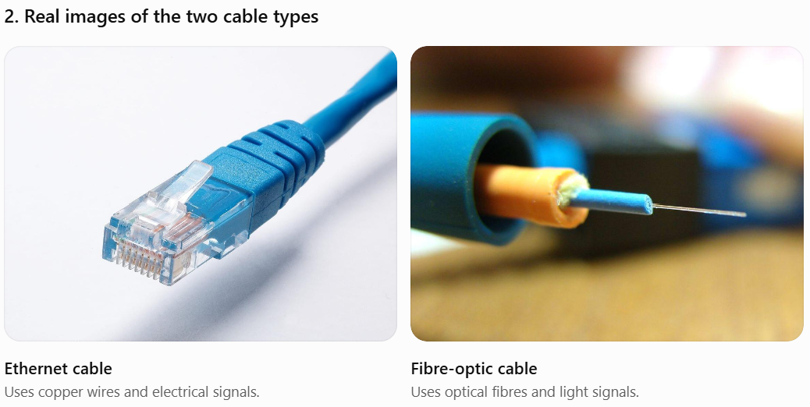
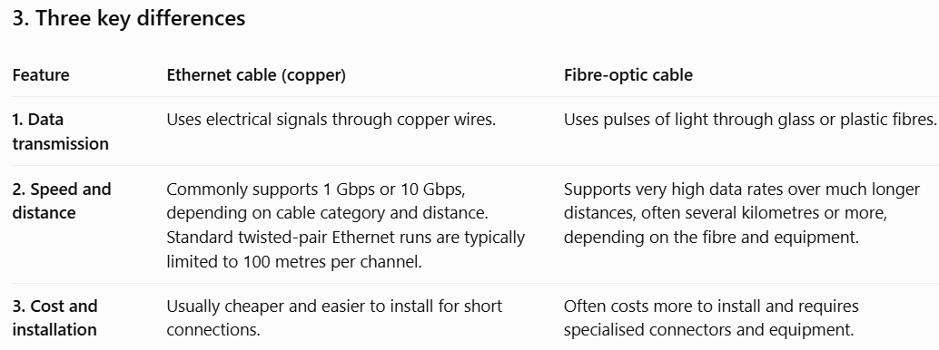

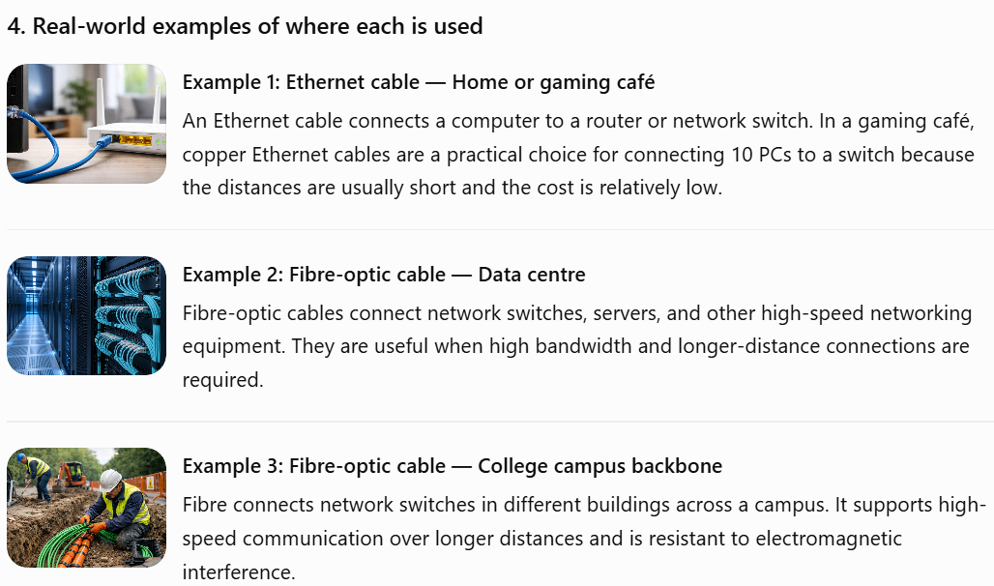
Ethernet and fibre-optic cables are both used to transmit data in computer networks, but they differ in their transmission methods, distance capabilities, and installation costs. Ethernet cables usually use copper wires to transmit electrical signals and are suitable for connecting computers to routers and switches in homes, offices, and gaming cafés. Fibre-optic cables transmit data using light signals and are suitable for high-speed, long-distance communication, such as connections between data centres and college buildings. Ethernet cables are generally more affordable for short connections, whereas fibre-optic cables are preferred for high-bandwidth backbone networks.
Important terms to remember:
- Bandwidth: The amount of data a connection can carry per second.
- RJ45 connector: The common connector used with copper Ethernet cables.
- Electromagnetic interference (EMI): Electrical or magnetic disturbances that can affect copper cable signals; fibre-optic cables are resistant to this type of interference.

2.Draw and label a diagram showing the internal wiring of a straight-through Ethernet cable (use T568B wiring standard), indicating the color of each wire and its pin number.

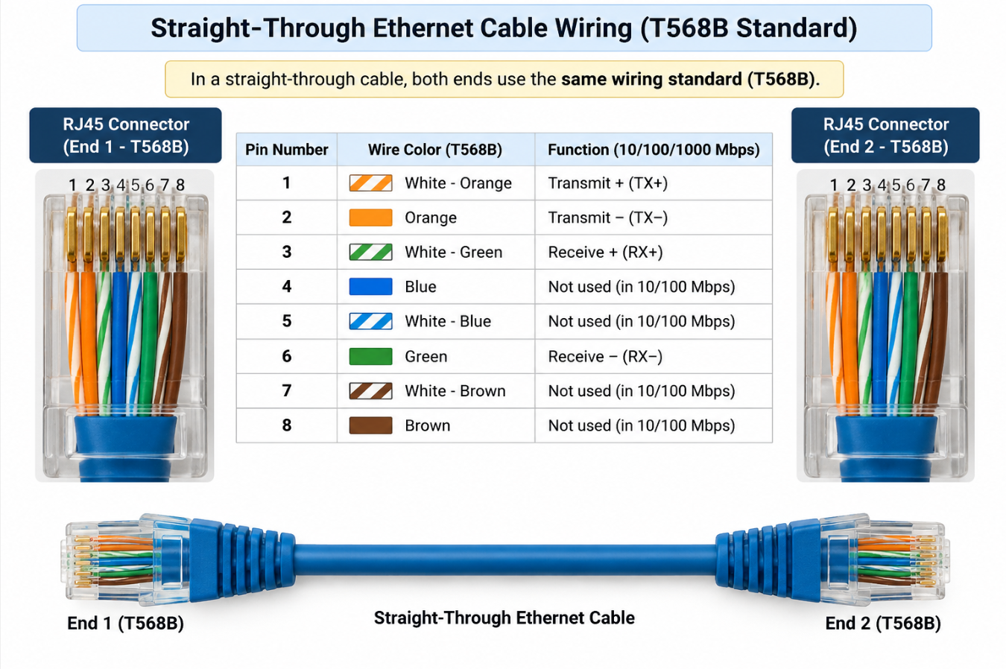
3.Watch a YouTube video demonstrating how to use an RJ45 crimper, then write a step-by-step guide (in your own words) on how to attach an RJ45 connector to a CAT6 cable.
Objective: To learn how to prepare a CAT6 Ethernet cable, arrange its wires according to the T568B standard, and attach an RJ45 connector using a crimping tool.
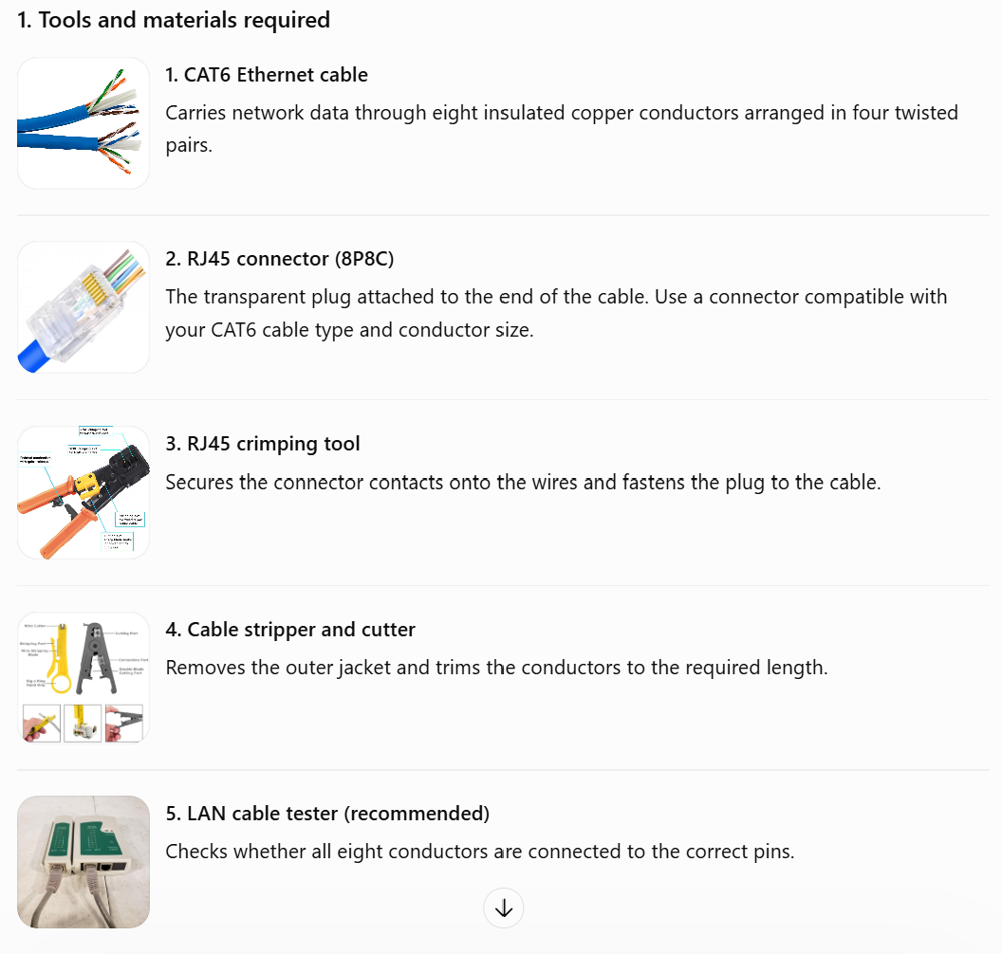
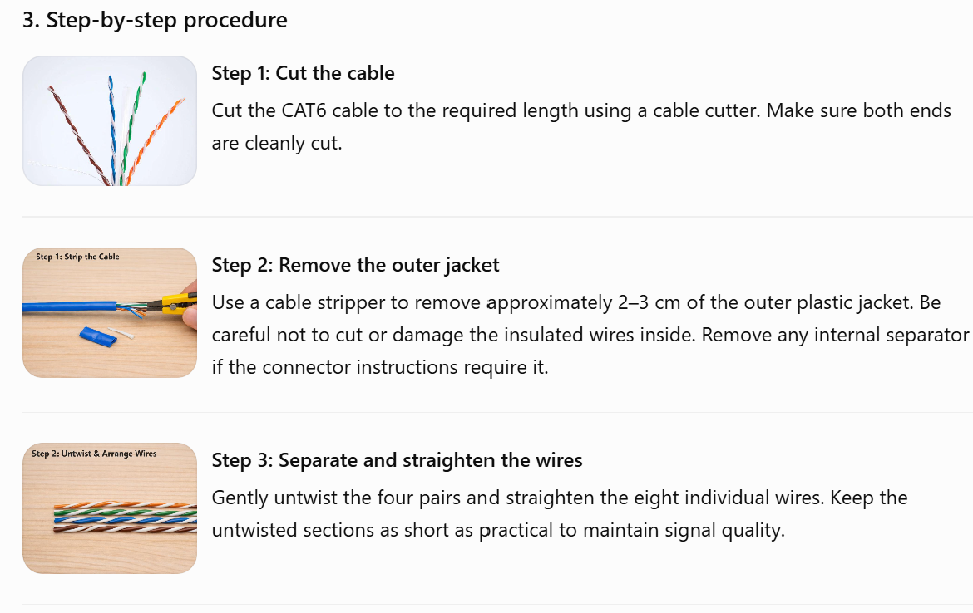
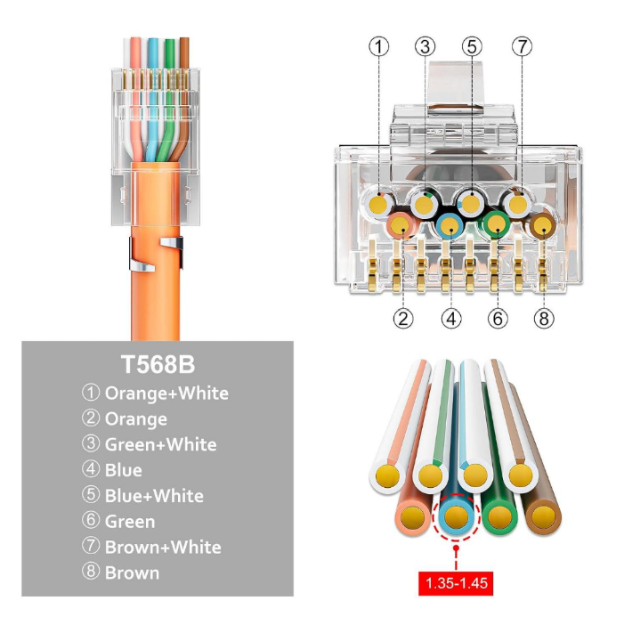
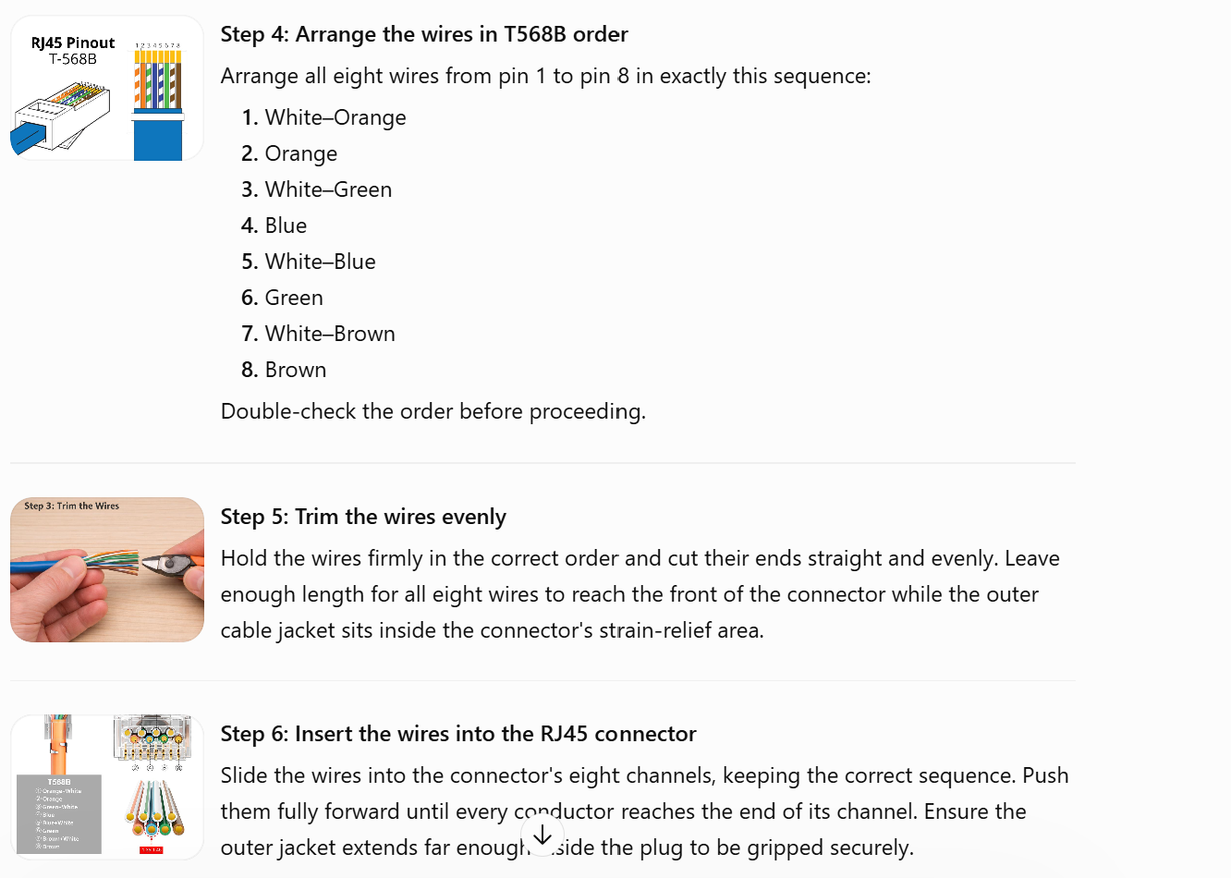

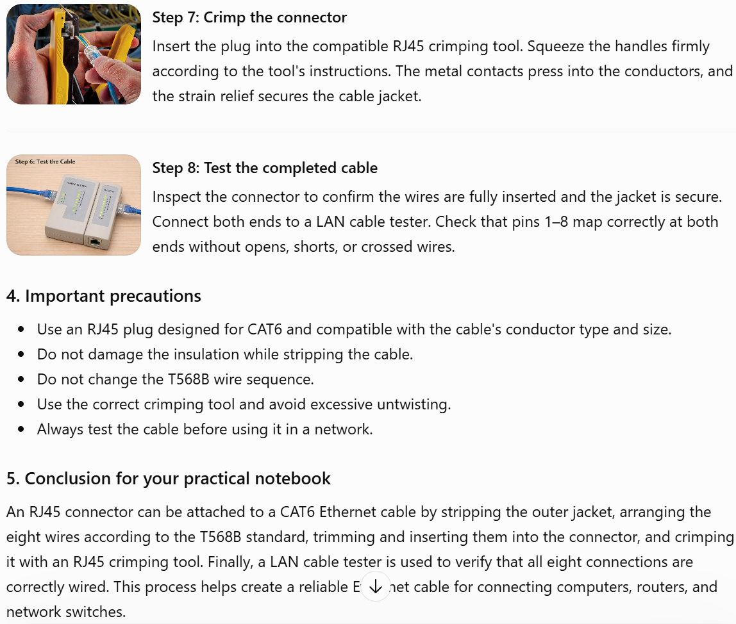
Remember: For a straight-through Ethernet cable, use the same wiring standard on both ends — T568B on both ends in this practical.
4.Imagine you are setting up a gaming café with 10 PCs for LAN gaming. Decide which cable type (Ethernet or fiber optics) and which tool (RJ45 crimper or fiber cleaver) you would use, and explain your choices in 3-4 sentences
For a gaming café with 10 PCs, I would choose CAT6 Ethernet cables to connect all the computers to a network switch because they provide high speed, low latency, and reliable connections for LAN gaming. Ethernet cables are suitable for the short distances between the PCs and the switch, and they are more affordable than fibre-optic cables for this setup. I would use an RJ45 crimping tool to attach RJ45 connectors to the CAT6 cables. Fibre-optic cables and a fibre cleaver are more suitable for long-distance connections, such as connecting different buildings or network backbones.

